Encapsulation

1. The meaning of **Encapsulation**, is to make sure that "sensitive" data is hidden from users. To achieve this, you must:

* declare class variables/attributes as private
* provide public **get** and **set** methods to access and update the value of a private variable

1. You learned from the previous chapter that private variables can only be accessed within the same class (an outside class has no access to it). However, it is possible to access them if we provide public **get** and **set** methods.
2. The get method returns the variable value, and the set method sets the value.
3. Syntax for both is that they start with either get or set, followed by the name of the variable, with the first letter in upper case:

Example :

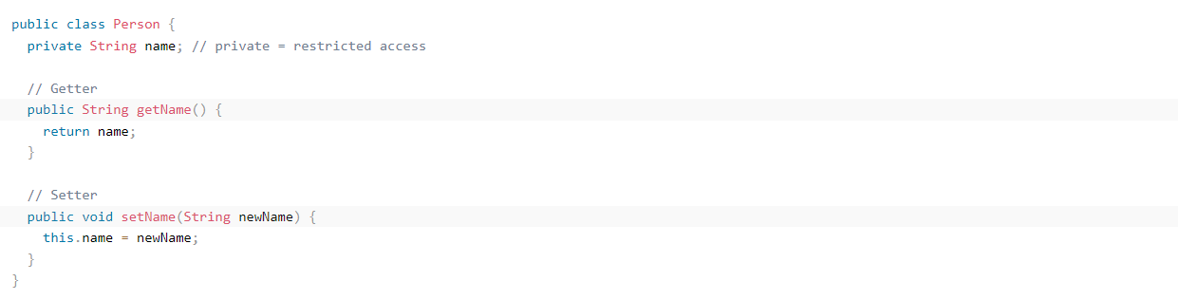

1. .